
press release

TRAVELLING WITH A FISHING ROD:
“FISHING TOURISM” IS THE NEW FRONTIER OF EXPERIENTIAL TOURISM

- In Europe, fishing generates an economic income of more than 10 billion euros
- In Italy, where sport tourism is worth 12 billion, the demand for tourist port services is growing
- New trends, from luxury charters in the Gulf of Naples to lodges in Denmark, will be featured from today until Sunday 15th February at Rimini Expo Centre with Italian Exhibition Group’s Pescare Show
www.pescareshow.it

Rimini, 13-15 February 2026 – No longer a solitary pastime, but a powerful motivation for travel able to move international flows and enhance locations all year round. Tourism linked to sport fishing is one of the most dynamic niches on the travel scene, intercepting the demand for nature, sustainability and authentic experiences. A phenomenon that will find a privileged observatory at Pescare Show 2026, Italian Exhibition Group’s (IEG) international sports fishing and recreational boating exhibition, scheduled to take place from Friday 13th to Sunday 15th February at Rimini Expo Centre.

THE NUMBERS: A FLYWHEEL FOR THE TOURISM ECONOMY
The figures show an extremely healthy sector. According to EFTTA (European Fishing Tackle Trade Association) estimates, the passion for fishing at a European level generates an annual expenditure of around 10.5 billion euros (between travel, equipment and experiences). Italy plays a leading role: with 2.5 million anglers and a domestic market that generates around 300 million euros in consumption (FIPO data), Italy is an increasingly coveted destination. The sector is part of the broader Italian sports tourism scene, which in 2024 reached a value of 12 billion euros, an increase of 8% on the previous year according to the Banca Ifis sports system observatory, driven by over 550,000 international travellers (+4.7% based on ENIT/Banca d’Italia findings).

TOURIST PORT EVOLUTION: FROM MOORINGS TO "EXPERIENTIAL HUBS"
The world of ports also confirms the change of pace. According to Assonat (National Association of Tourist Docks and Ports), demand for Italian marinas is evolving: no longer just the “do-it-yourself” boat owner, but an international clientele - with a considerable increase from the USA - who are looking for professional charter services, technical assistance and high comfort. As Assonat underlines, sport fishing is a concrete lever for extending the offer and intercepting new segments. Ports are becoming authentic tourist hubs able to collaborate with chefs, museums and hospitality facilities to enhance the identity of the location. A strategic asset also for deseasonalisation: flows linked to fishing are, in fact, distributed throughout the year, bringing life to tourist ports even away from the summer season.

SUSTAINABILITY AND "CATCH & RELEASE"
The new tourist-angler is attentive to the environment. The most common practice is Catch & Release, supported by “green” innovations such as electric motors for silent sailing. A sensitivity also recognized by tourist ports which, as Assonat highlights, are investing increasingly in waste management, photovoltaics and marine ecosystem protection.

DESTINATIONS FEATURED AT RIMINI: FROM THE ALPS TO THE FAR NORTH
At Pescare Show 2026, travel will cross Europe starting from the “cold paradises”. Denmark will stand out with the island of Fyn and the archipelago (Langeland and Ærø), renamed the capital of sea trout thanks to the thirty-year Havørred Fyn environmental restoration project. Here, excellent facilities such as the Denmark Fishing Outdoor Lodge offer high-level services and exclusive access to private waters for pike fishing. For those seeking extreme adventure, Go to Fish offers tailor-made itineraries to Norway for halibut and cod fishing, and even to Greenland waters for Arctic char.
In Italy, the offer combines biodiversity and professional services. Trentino offers 300 alpine lakes and 2000 km of waterways thanks to online Trentino Fishing Guides, local experts who can also be booked via smartphone. In Friuli Venezia Giulia, the Carnia Fishing Guide association proposes a slow and “no-kill” tourism model, where fishing becomes a cultural means to discover local history, food and wine. The South responds with the luxury of the Mediterranean: in the Gulf of Naples, Virada Fishing Experience raises the concept of charter by offering exclusive outings on board the Pursuit 3100 Offshore, combining the adrenaline of professional sport fishing with the iconic beauty of the Neapolitan landscape.

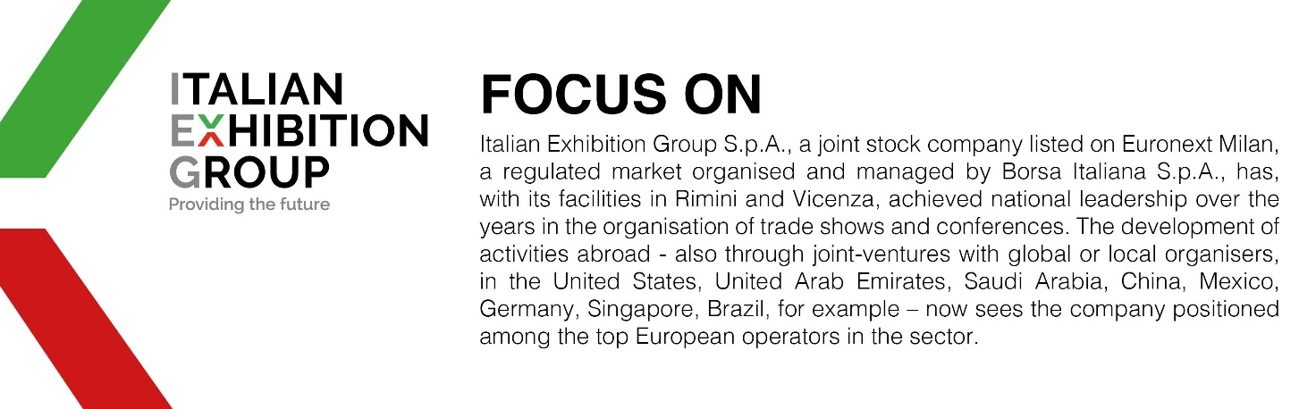

ABOUT PESCARE SHOW 2026
Organisation: Italian Exhibition Group S.p.A. Entry: trade and the public (from Friday 13th to Sunday 15th February 2026, Rimini Expo Centre), 2nd edition; www.pescareshow.it; Facebook: www.facebook.com/pescare.show; Instagram: www.instagram.com; YouTube: www.youtube.com; #pescareshow26.

PRESS CONTACT - ITALIAN EXHIBITION GROUP
head of media & corporate communication: Elisabetta Vitali; press office manager: Marco Forcellini, Pier Francesco Bellini; press office coordinator: Luca Paganin; international press office coordinator: Silvia Giorgi; press office specialists: Nicoletta Evangelisti, Mirko Malgieri; media@iegexpo.it; stage press office: Julia Andreatta

Media Agency Eprcomunicazione S.p.A.
0444 512550; Giulia Lucchini, mob. +39 348 7853679, lucchini@eprcomunicazione.it; Francesca Magnanini magnanini@eprcomunicazione.it

This press release contains forecasted elements and estimations that reflect current management opinions (“forward-looking statements”) especially regarding future managerial performances, investments, cash flow trends and financial organization evolution. By nature, forward-looking statements have an element of risk and uncertainty since they depend on future events. The effective results may therefore differ, even significantly, to those announced due to multiple factors including, merely by way of example: the catering market’s foreign trends and tourist flows in Italy, market trends in the gold-jewelry industry and in the green economy; developments in the price of raw materials; general macro-economic conditions; geo-political factors and changes in the legislative framework. Furthermore, the information in this press release does not claim to be complete, nor has it been verified by independent third parties. The forecasts, estimations and objectives presented herein are based on information available to the Company at the press release issue date

